Vince M Milisauskas, Brianna Muleski, Alex Mueller

Team FQJ

Phase II:   
Systems Requirement Document on System Analysis

Personal Trainer, Inc.

CUSTOMER INFORMATION SYSTEM

Personal Trainer, Inc.

Customer Information System

Table of Contents

1. Introduction 2

1.1. Background of the Case 2

1.2. Summary 2

2. Systems Requirement 3

2.1. Functional Requirements 3

2.2. Non-Functional Requirements 3

2.3. Functional Decomposition Diagram 4

3. Use Case Scenarios 5

4. Data and Process Model 5

4.1. Data Flow Diagrams 5

4.2. Data Dictionary 9

4.3. Process Descriptions 9

5. Object Model 10

5.1. Use Case Diagram 10

5.2. Class Diagram 10

Table of Figures/Tables

Figure 1: Organization Chart 3

Table 1: Task Schedule 7

# Introduction

## Background of the Case

Personal Trainer Inc owns and operates fitness centers in a dozen Midwestern cities. They are expanding and opening a supercenter in the Toronto area. The president Cassia Umi has 3 mangers report to her. The new supercenter will be start of the art with various exercise equipment for the members. Cassia wants to have online access to customized training programs and progress for its members. With the use of BumbleBee, most of their accounting needs are handled. There is a plan for two levels of membership to be available, gold and silver. Silver members have limited access and gold have unlimited access. Cash sales and charges are entered at the end of the day through BumbleBee. This is done by a local workstation at each location. BumbleBee produces a daily report as well. At the end of month there is an accounts receivable summary that gets produces a sent to HQ. Member’s payments are mailed into HQ as well. The managers and other staff have a wish list of things that they want. Such as trend spotting, better information about profits, more computerized activity, wellness logs, social media communication, and ID cards to hold members data.

## Summary

TODO

# Systems Requirement

## Functional Requirements

* The system shall keep the following member information:
  + Member ID
  + Password
  + Name
  + Birthday
  + Membership level
  + Wellness logs
  + Progress Reports
* The system shall allow member access to member information through the website.
* The system shall allow a member access to their wellness logs through the website.
* The system shall allow a member to pay for their services through the website.
* The system allow adding new members.
* The system shall allow removing members.
* When a member is removed, the system shall allow reuse of that member’s member card.
* The system shall allow a member to sign-up for a trainer class through the website.
* The system shall allow a staff member to modify a member’s membership level.
* The system shall update wellness logs when member card is scanned.
* When a member card is scanned, the system shall verify correct membership level for access.
* When membership level is not allowed access, the system shall deny access to the member.
* The system shall track member usage through wellness logs and accessed fitness areas.
* The system shall alert a manager of unpaid memberships.
* The system shall keep the following trainer information:
  + Trainer’s Name
  + Current classes
  + Rate
  + Review
* The system shall allow members to rate a trainer.
* The system shall allow members to review a trainer.
* The system shall allow a trainer to update their information.
* The system shall allow adding new trainers.
* The system shall allow removing trainers.

## Non-Functional Requirements

* The system shall allow workstation access during business hours.
* The system shall allow website access at all times.
* The system shall boot within 5 seconds on a powered-on workstation.
* The system shall restrict removal of members to staff members.
* The system shall run the website on mobile devices.
* The system shall support 400 simultaneous users at all times.
* The system shall restrict member usage tracking information to managers
* The system shall restrict viewing member’s payment information to member.

## Functional Decomposition Diagram

Figure : Functional Decomposition Diagram

# Use Case Scenarios

# Data and Process Model

## Data Flow Diagrams

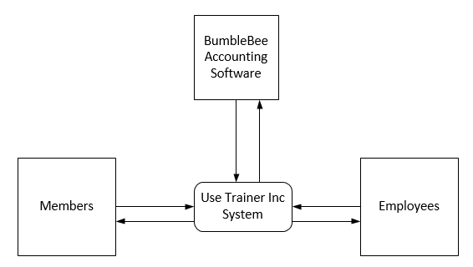

Figure : Context Diagram

The general data flow diagram was broken up into 4 different diagrams: 2 diagrams involving Members and their interaction with the system, 1 diagram involving the use of the Trainers, and 1 data flow involving the manager’s interaction with the system.

Member Data Flows:



Figure : Member Data Flow Diagram 1



Figure : Member Data Flow Diagram 2

Refined ‘Sign-up For Class’ Process:



Figure : Refined Process 6

Trainers Data Flow:



Figure : Trainer Data Flow Diagram

Managers Data Flow:



Refined ‘View Member Usage’ Process:



Figure : Refined Process 12

Refined ‘View Delinquent Accounts’ Process:



Figure : Refined Process 13

## Data Dictionary

## Process Descriptions

# Object Model

## Use Case Diagram



## Class Diagram